**SQL ASSIGNMENT**

1. Create the above table.

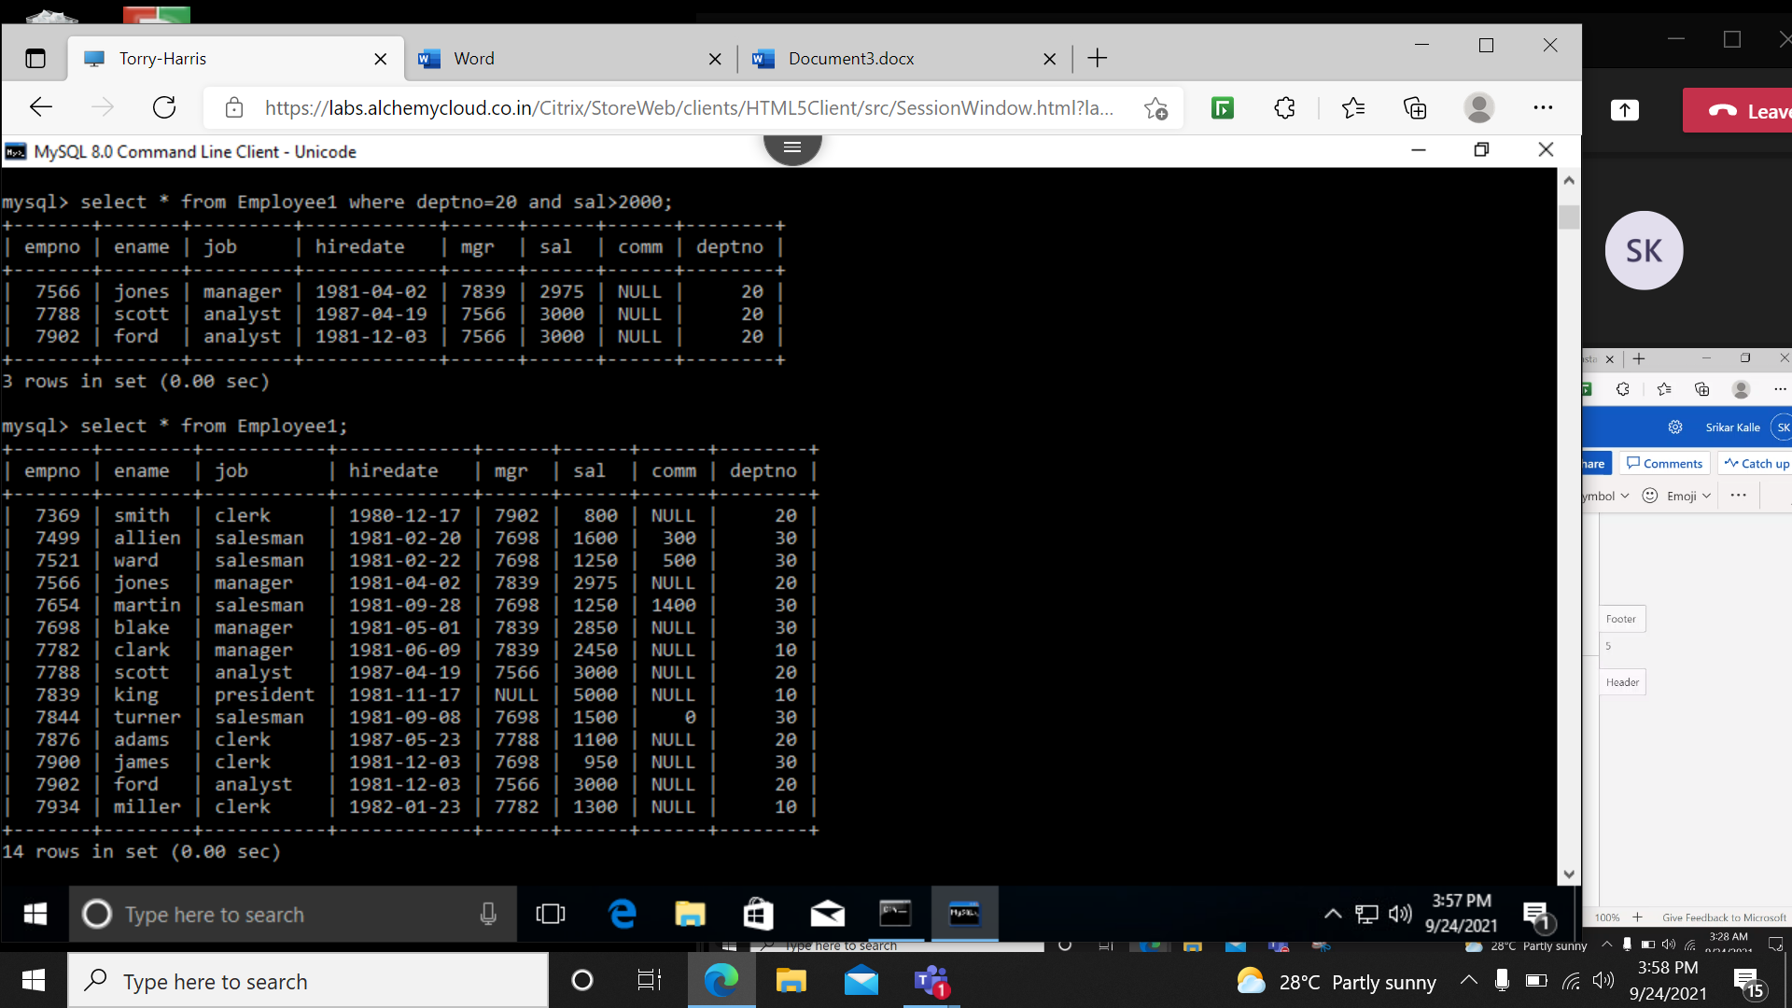

1. Select the employees in department 30.

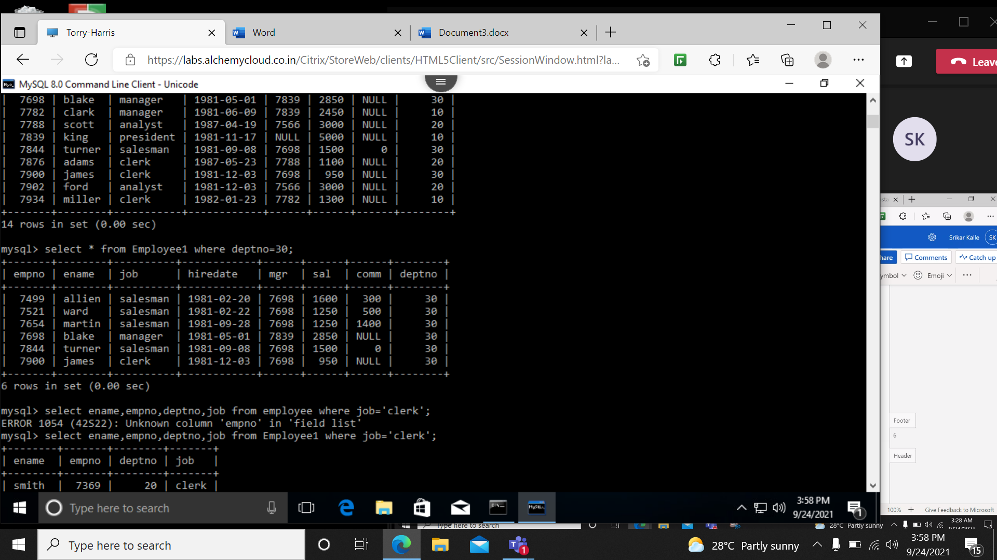

1. List the names, numbers and departments of all clerks.

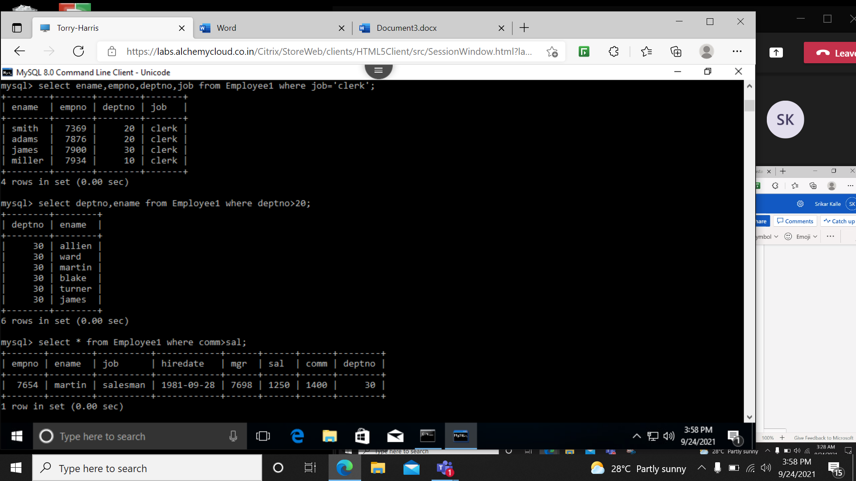

1. Find the department numbers and names of employees of all departments with depno greater than 20.



1. Find employees whose commission is greater than their salaries.



1. Find employees whose commission is greater than 60% of their salaries.

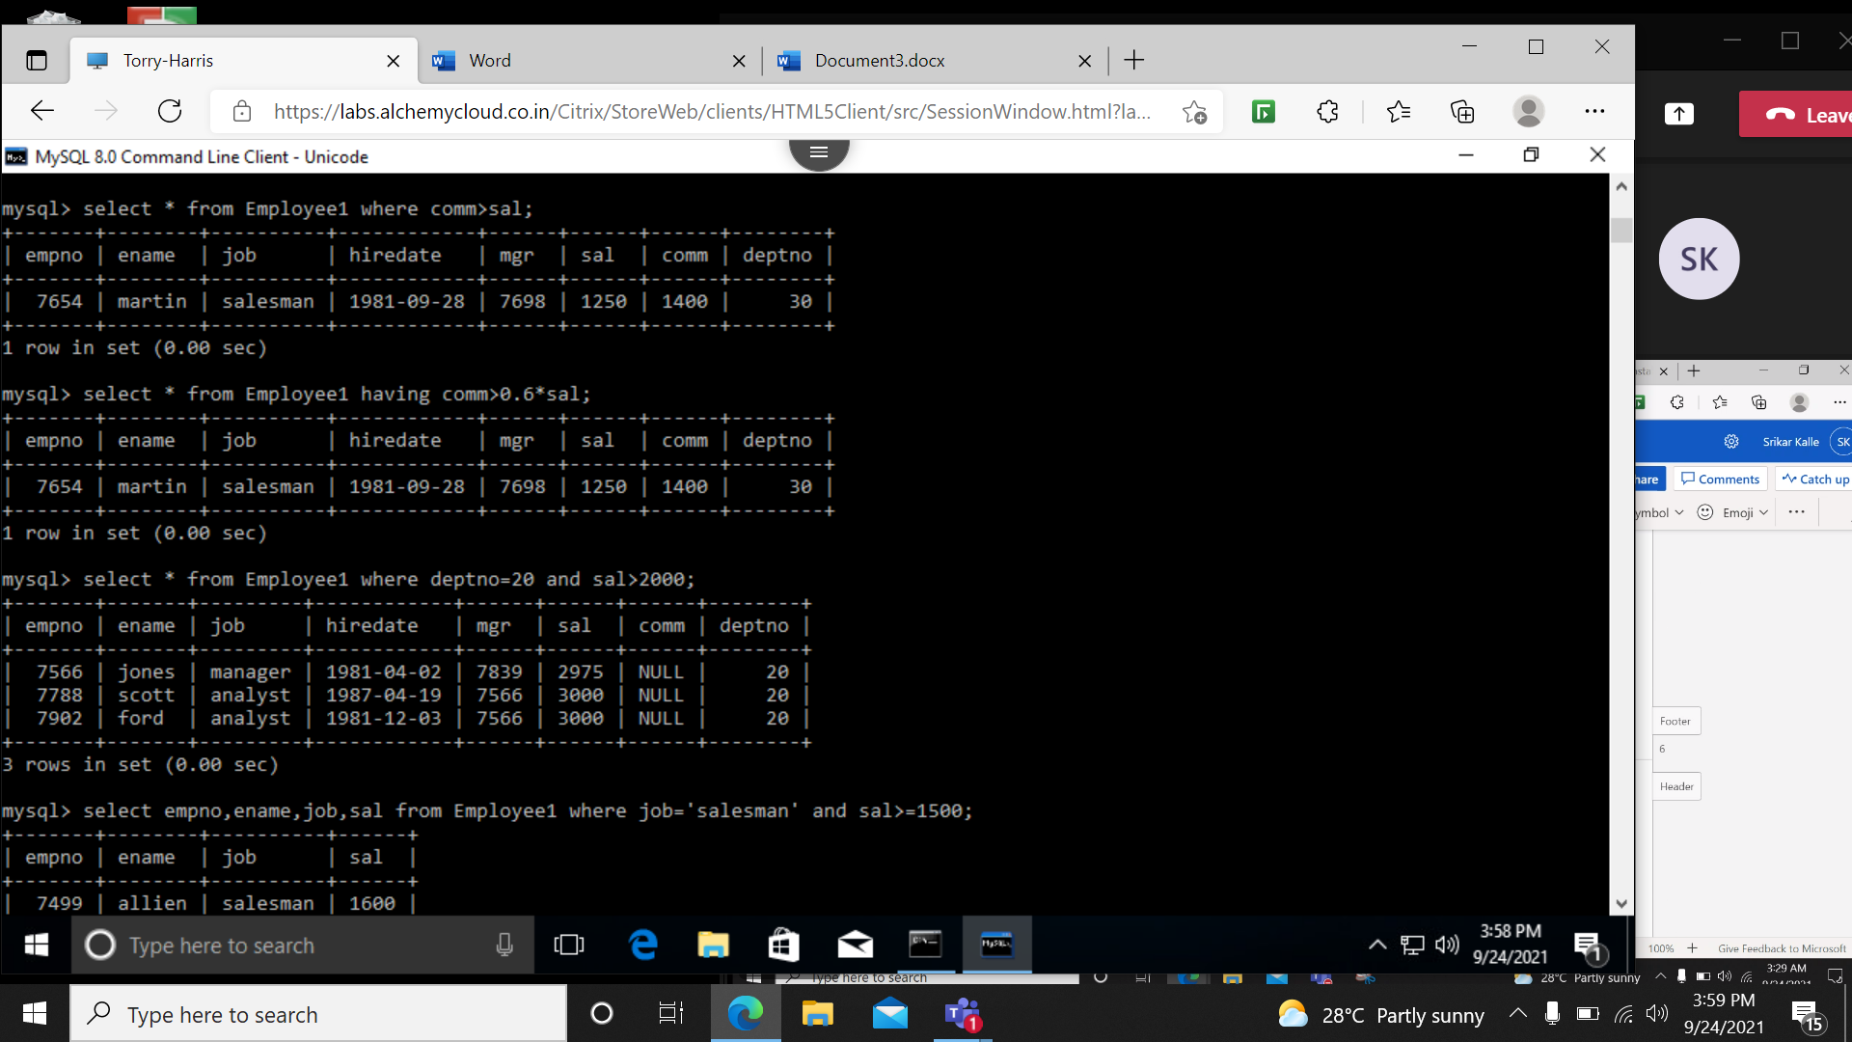

1. List name, job and salary of all employees in department 20 who earn more than 2000/-.

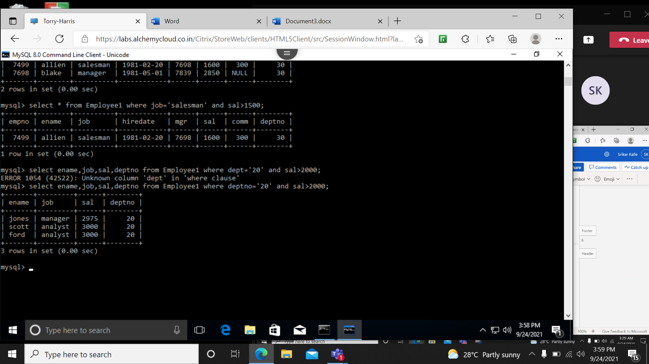

1. Find all salesman in department 30 whose salary is greater than 1500/-.

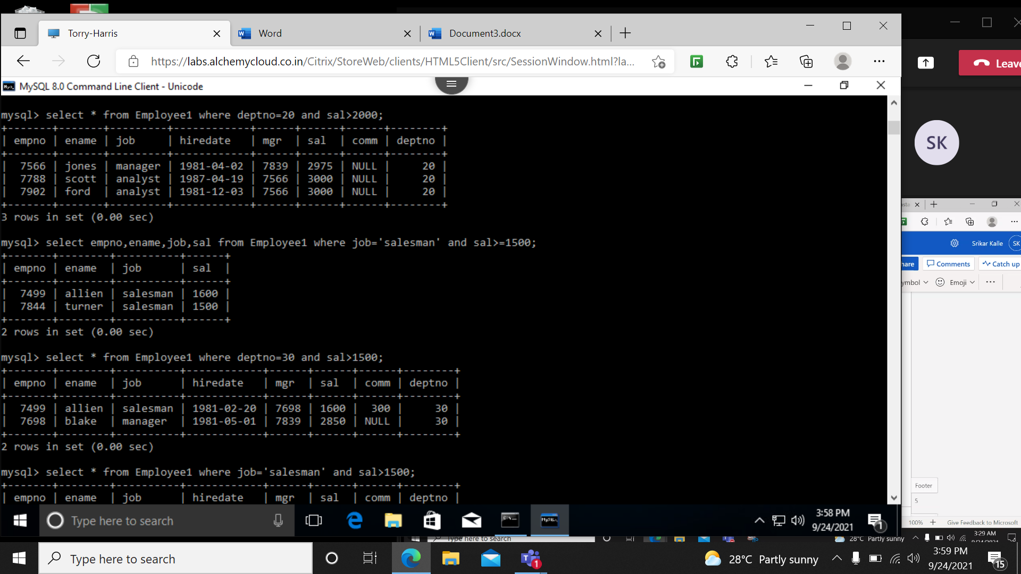

1. Find all employees whose designation is either manager or president.

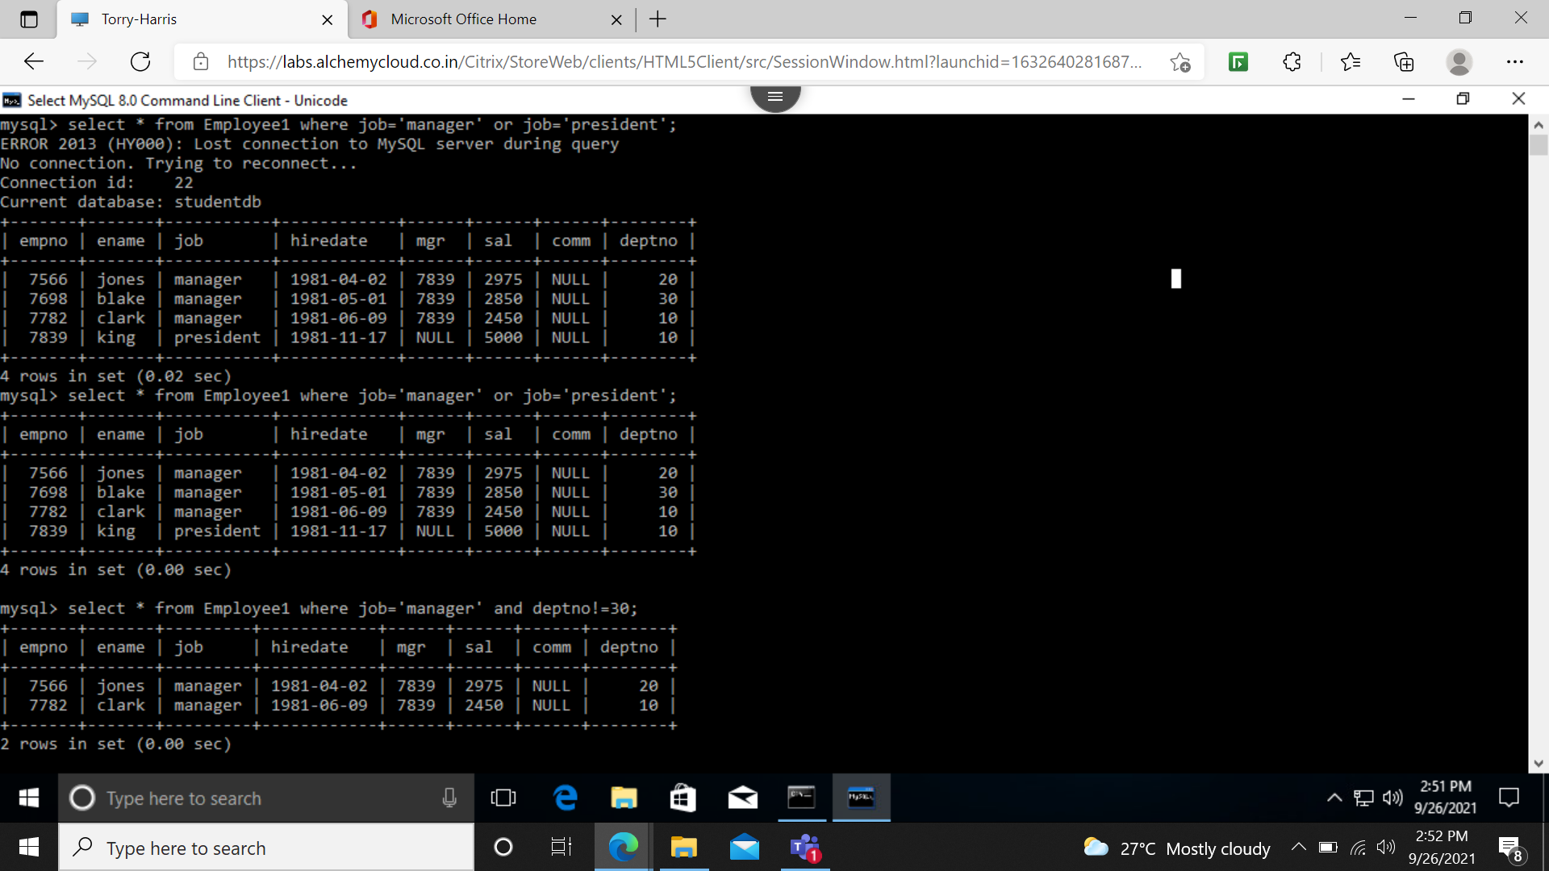

1. Find all managers who are not in department 30.



1. Find all the details of managers and clerks in dept 10.

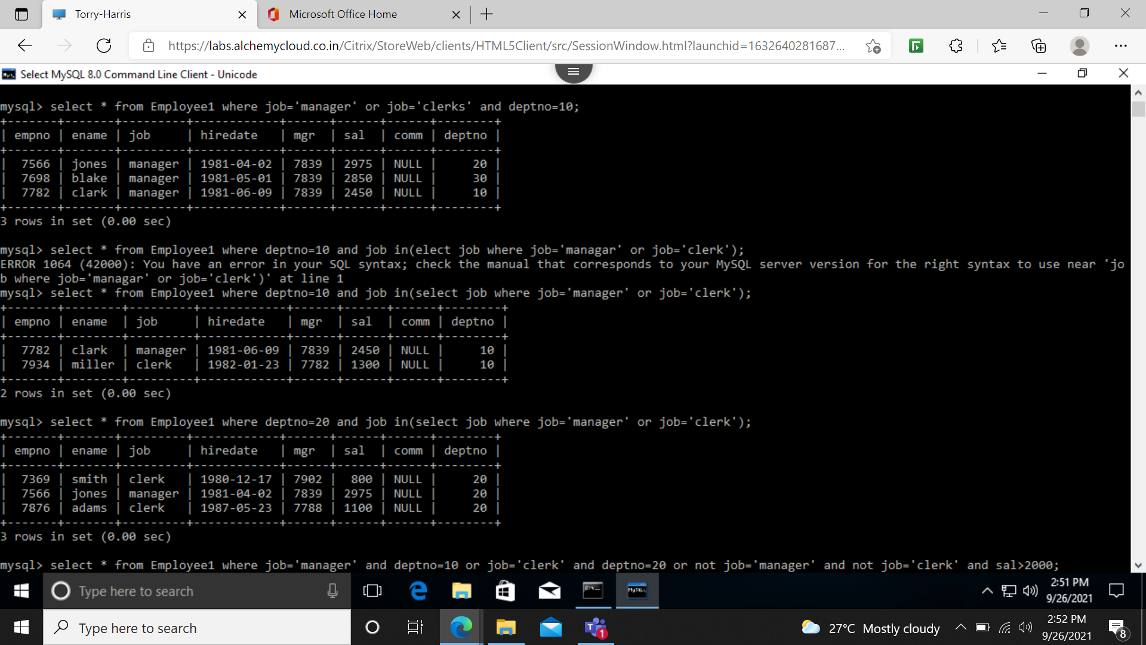

1. Find the details of all the managers (in any dept) and clerks in dept 20.



1. Find the details of all the managers in dept 10 and all clerks in dept 20 and all employees who are neither managers nor clerks but whose salary is more than or equal to 2000/-.

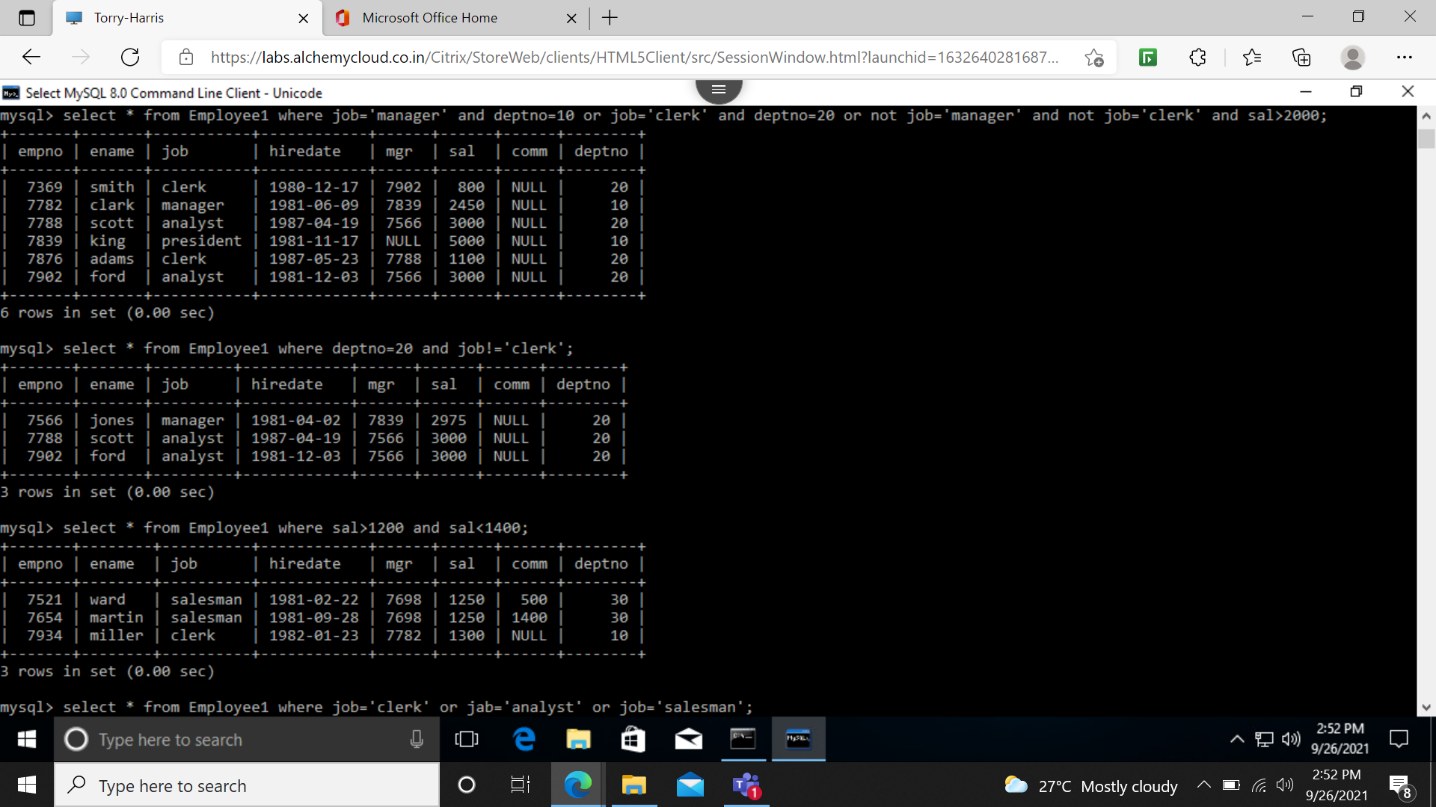

1. Find the names of anyone in dept 20 who is neither manager nor clerk.



1. Find the names of employees who earn between 1200/- and 1400/-.



1. Find the employees who are clerks, analysts or salesmen.

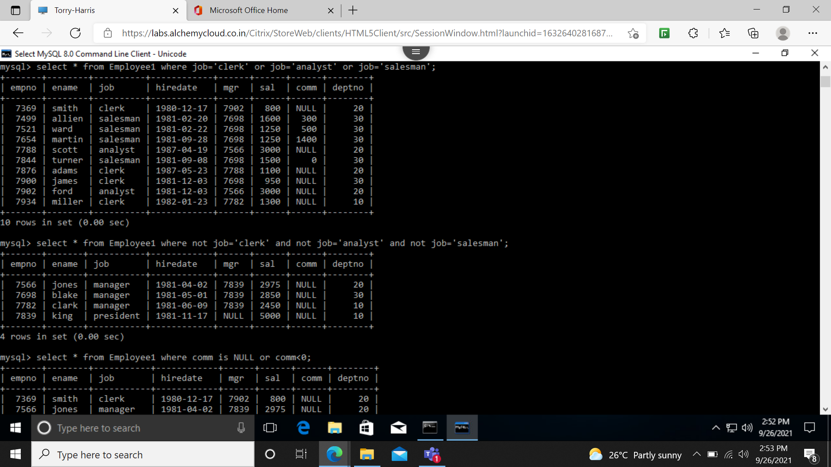

1. Find the employees who are not clerks, analysts or salesmen.



1. Find the employees who do not receive commission.

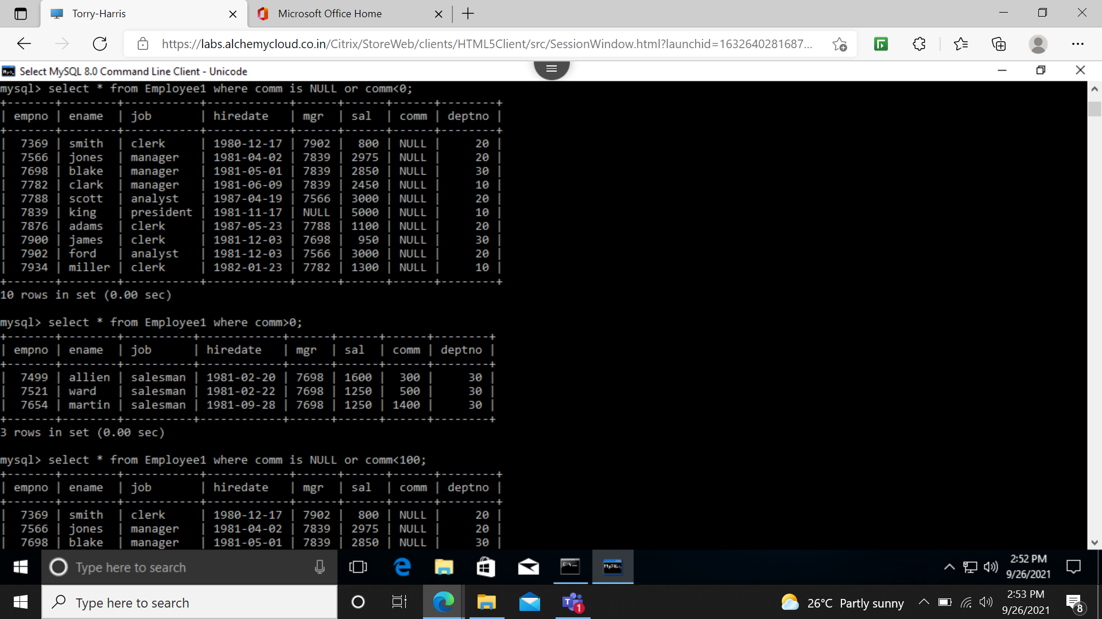

1. Find the different jobs of employees receiving commission.



1. Find the employees who do not receive commission or whose commission is less than 100/-.

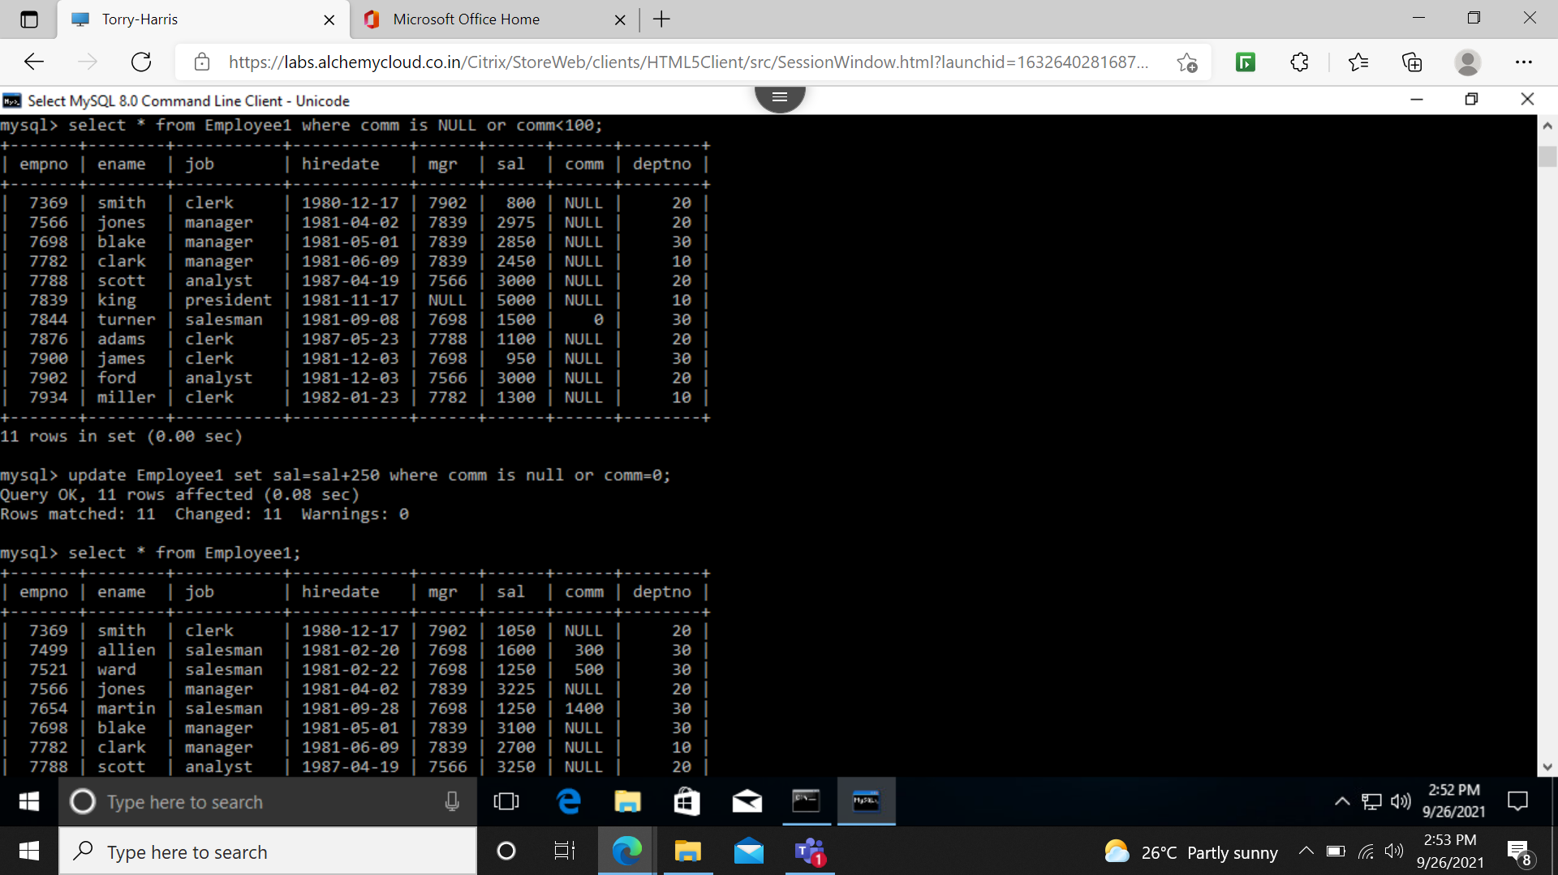

1. If all the employee's not receiving commission is entities to a bonus of Rs.250/- show the m net earnings of all the employees.

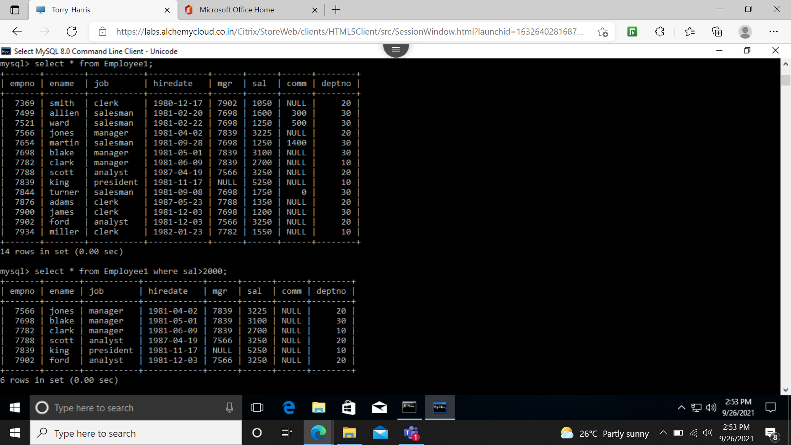

1. Find all the employees whose total earning is greater than 2000/-.



1. Find all the employees whose name begins or ends with ‘M’

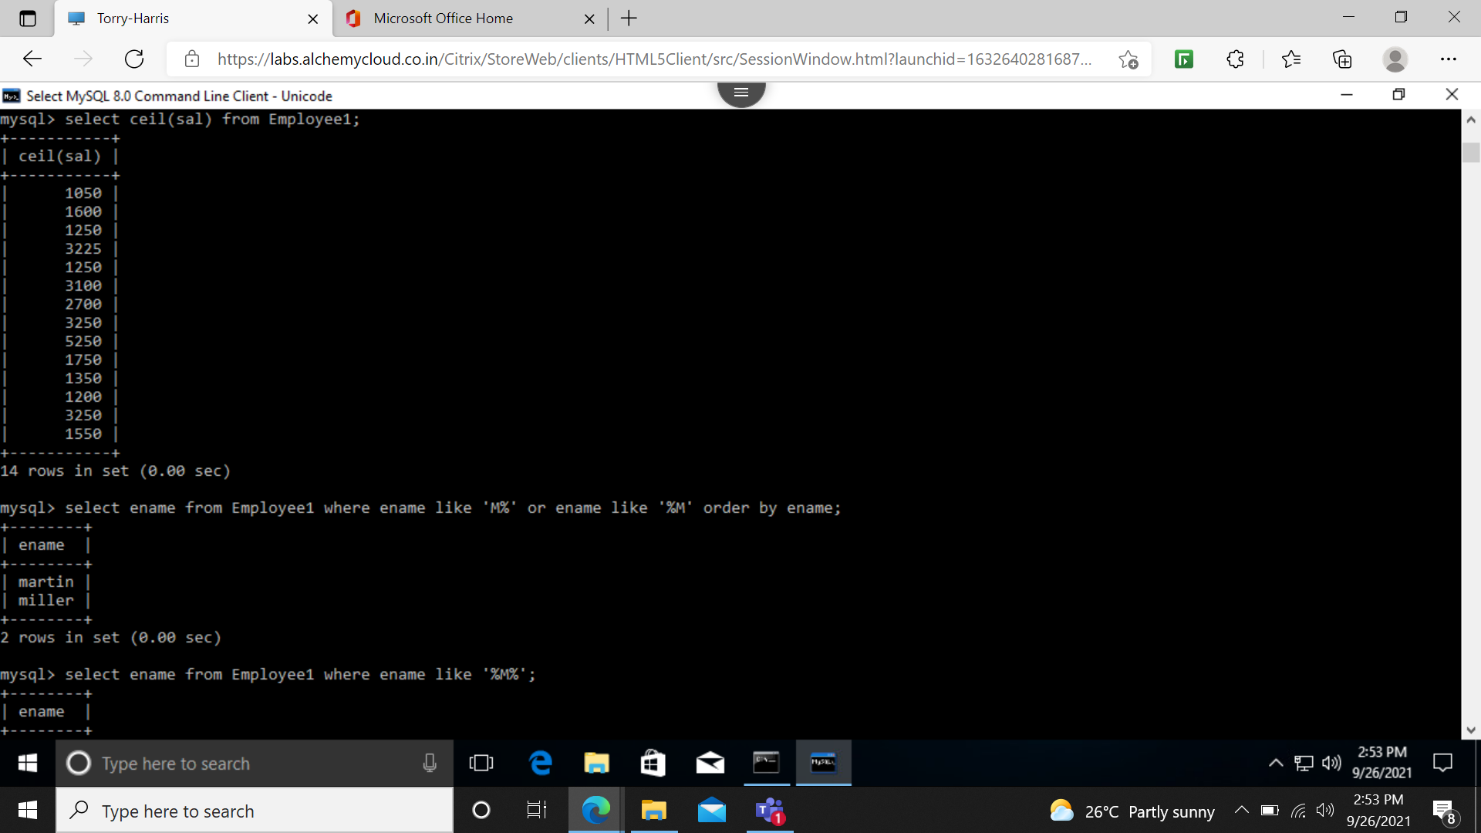

1. Find all the employees whose names contain the letter ‘M’ in any case.

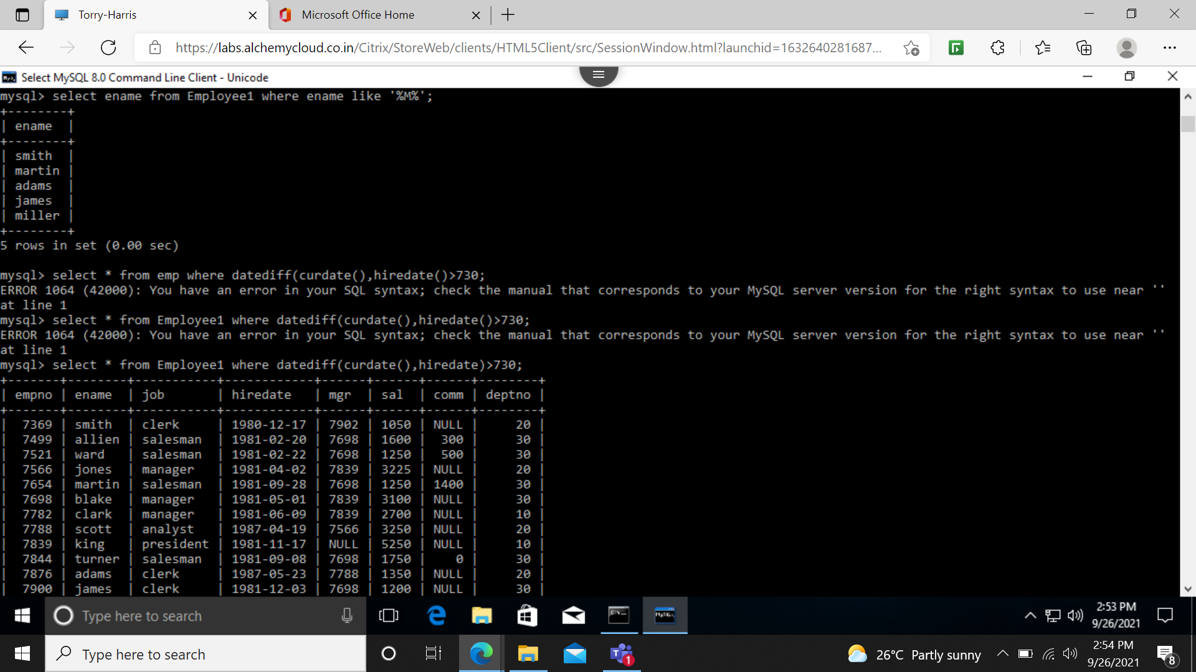

1. Find all the employees whose names are up to 15 characters long and have letter ‘R’ as 3rd character of their names.



1. Find all the employees who were hired in the month of February (of any year).

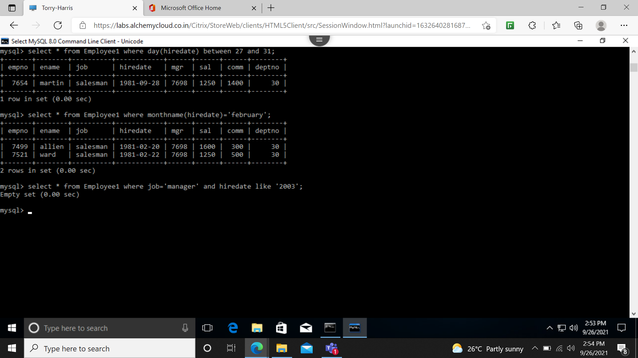

1. Find all the employees who were hired on last day of the month.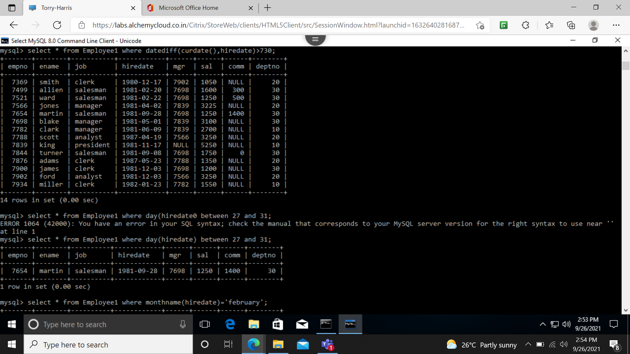
2. Find all the employees who were hired more than 2 years ago.
3. Find the managers hired in the year 2003.

